**Task 5 for submission**

*Parts A & B address the following unit objectives:*

***Unit Objective 3 – analyse and interpret financial data and information relating to accounting and end-of-year reporting for a trading business***

***Unit Objective 4 – evaluate accounting practices relating to accounting and end-of-year reporting for a trading GST business to make decisions and propose recommendations***

***Unit Objective 6 – create responses that communicate meaning to business owners and managers of a trading GST business***

***Part A***

|  |
| --- |
| **Analyse and interpret** thefollowing information including the credit application document. |
| You are required to **create** a business report (extract) that **evaluates** Ima Looznalot’s accounting practices relating to controls over accounts receivable. Your 300 – 400 word business report (extract) must: |
| •   identify two issues regarding Ima’s current position and processes for accounts receivable  •   **recommend** any changes which may improve the issues identified   * **justify** any recommendations made |

***The case of Ima Looznalot …***

Ima Looznalot commenced a food distribution business, Variety Victuals, 3 years ago. She made a decision 12 months ago to provide a credit facility to those customers who applied. Ima put into place a creditworthiness check. All potential customers had to complete the attached credit application document. The terms and conditions that Ima was prepared to trade under were provided on the credit application document.

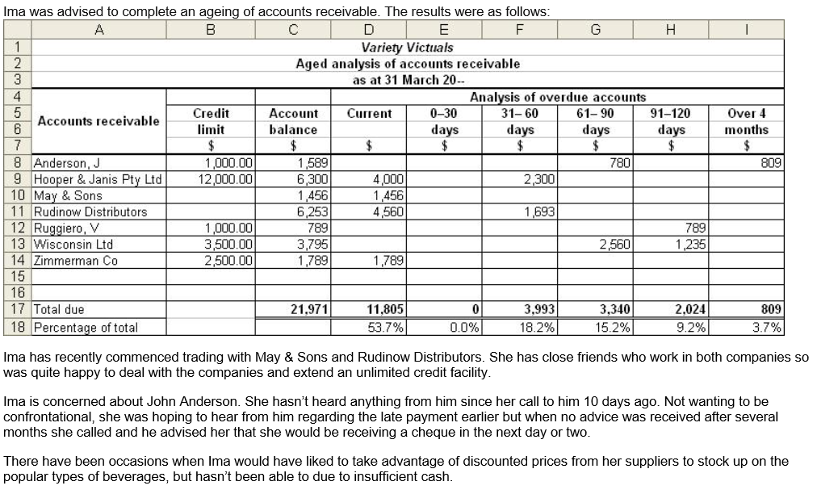

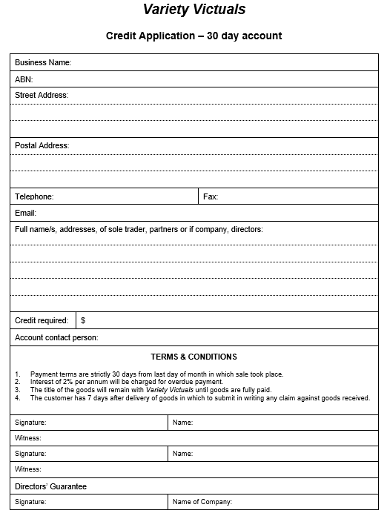

***Part B***

|  |
| --- |
| **Analyse and interpret** the following information for TOPIC Spare Parts. |
| You are required to **create** a business report (extract) for the owner, Salman Rahan which **evaluates** his accounting practices relating to controls over inventories. Your 300 – 400 word business report (extract) must: |
| •   identify issues regarding Salman’s current processes for controls over inventories  •   **recommend** any changes which may improve the current practices   * **justify** any recommendations made |

Salman Rahan has been operating for the past two years a car spare parts business, *TOPIC* (The Omitted Piece in Cars*)* *Spare Parts*.

He operates out of premises which have a front office/retail section and large store warehouse behind the office/retail section. There is a large quantity of stock displayed on shelving in the retail section and for this reason security cameras have been installed in the area as a preventative measure against theft. An insurance been taken out which covers stock loss in case of flood, burglary, etc. There is an entrance to the warehouse section which is kept unlocked during the day because there are frequent deliveries and the staff, are not always available to provide access to delivery people. Rahan has asked his staff to unpack deliveries in the quieter times of the day, when they have an opportunity to do so. He doesn’t want to have boxes piled up blocking the entrance to the warehouse.

Rahan believes that he has to have whatever a customer wants when they walk in the store, otherwise he’ll miss out on business. He doesn’t have much time to do checking of stock so he just makes regular orders to his suppliers, hence the frequent deliveries. He has been using the same suppliers since he commenced business and has found it convenient to do business with them. He knows they have the stock and will deliver it 2 days after he orders it.

**Report (extract) on controls over inventories**

**ISSUES IDENTIFIED**

**Control over storage**

The business premises include a warehouse for the storage of inventories and a retail section which has inventories displayed on shelving. These would appear to be appropriate storage for the inventories.

**Security controls**

The installation of security cameras in the retail section is a very good control measure to guard against theft and so too is the insurance coverage for theft and damage. However, there are areas lacking in security control.

The entrance to the warehouse should not be left unlocked. This provides an opportunity for anyone to have access to stock. It would also impede any insurance claim for theft.

**Maintaining and monitoring levels of inventories**

There is an urgent need for control over the monitoring of inventory levels. There appears to be no system in place for the recording of stock and monitoring of stock levels. It is recommended that the perpetual inventory system is implemented so that the movement of individual items of stock can be recorded on stock cards ensuring that the correct number of stock is ordered when required. A reorder point – the minimum number of inventories required to be on hand – and the reorder quantity should be established for every item. Too much stock on hand means that the money is tied up which could have been put towards other means of generating profit.

**Control over purchasing and delivery of inventories**

When stock is delivered to the premises it should be carefully checked against what has been ordered, i.e. it should be checked for quality, number of stock delivered and possible damage. There should be one person responsible for signing off the delivery, unpacking and storing of stock as soon as it is received.

It is recommended that periodic checks on the prices and quality of goods are conducted to compare with prices and quality of goods from other competitive suppliers to ensure that the business is not paying too much for stock.

**PROPOSED CHANGES/Recommendations**

Some control measures over inventories are in place. However, it is highly recommended that the business must implement further controls immediately. These include:

* keeping the warehouse locked at all times
* perpetual inventory system implemented – movement of individual items of stock continuously recorded; providing levels of each item; ensuring that overstocking of items does not occur
* assigning responsibility to one person for the receiving of stock
* periodic checks on prices and quality provided by other suppliers